转载自：soul orbit: <http://r12f.com/posts/sonic-5-syncd-sai-workflow/>

# SONiC学习笔记（五）：Syncd-SAI工作流

（以下内容已经整合进《SONiC入门指南》的 [SAI介绍](https://r12f.com/sonic-book/2-4-sai-intro.html) 和 [Syncd-SAI工作流](https://r12f.com/sonic-book/5-1-syncd-sai-workflow.html) 两节中。）

[Syncd容器](http://r12f.com/posts/sonic-2-key-components/" \l "ASIC%E7%AE%A1%E7%90%86%E5%AE%B9%E5%99%A8%EF%BC%9Asyncd)是SONiC中专门负责管理ASIC的容器，其中核心进程syncd负责与Redis数据库沟通，加载SAI并与其交互，以完成ASIC的初始化，配置和状态上报的处理等等。

由于SONiC中大量的工作流最后都需要通过Syncd和SAI来和ASIC进行交互，所以这一部分也就成为了这些工作流的公共部分，所以，在展开其他工作流之前，我们先来看一下Syncd和SAI是如何工作的。

## **1. Syncd启动流程**

syncd进程的入口在syncd_main.cpp中的syncd_main函数，其启动的整体流程大致分为两部分。

第一部分是创建各个对象，并进行初始化：

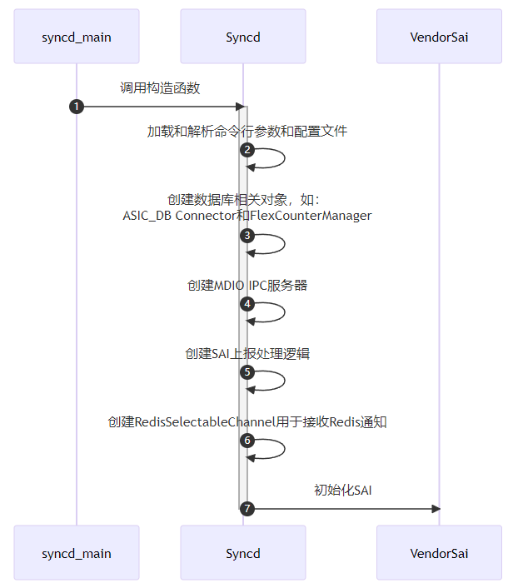

第二个部分是启动主循环，并且处理初始化事件：

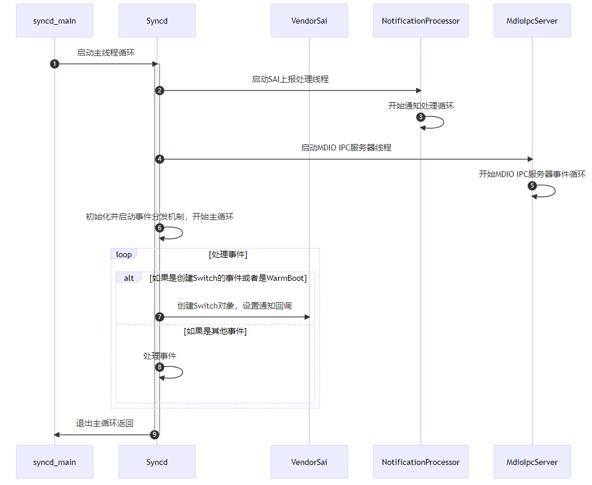

然后我们再从代码的角度来更加仔细的看一下这个流程。

### **1.1. syncd_main函数**

syncd_main函数本身非常简单，主要逻辑就是创建Syncd对象，然后调用其run方法：

|  |
| --- |
| *// File: src/sonic-sairedis/syncd/syncd_main.cpp* int syncd_main(int argc, char **argv) {  auto vendorSai = std::make_shared<VendorSai>();  auto syncd = std::make_shared<Syncd>(vendorSai, commandLineOptions, isWarmStart);  syncd->run();  return EXIT_SUCCESS; } |

其中，Syncd对象的构造函数负责初始化Syncd中的各个功能，而run方法则负责启动Syncd的主循环。

### **1.2. Syncd构造函数**

Syncd对象的构造函数负责创建或初始化Syncd中的各个功能，比如用于连接数据库的对象，统计管理，和ASIC通知的处理逻辑等等，其主要代码如下：

|  |
| --- |
| *// File: src/sonic-sairedis/syncd/Syncd.cpp* Syncd::Syncd(  _In_ std::shared_ptr<sairedis::SaiInterface> vendorSai,  _In_ std::shared_ptr<CommandLineOptions> cmd,  _In_ bool isWarmStart):  m_vendorSai(vendorSai),  ... {  ...  *// Load context config*  auto ccc = sairedis::ContextConfigContainer::loadFromFile(m_commandLineOptions->m_contextConfig.c_str());  m_contextConfig = ccc->get(m_commandLineOptions->m_globalContext);  ...  *// Create FlexCounter manager*  m_manager = std::make_shared<FlexCounterManager>(m_vendorSai, m_contextConfig->m_dbCounters);  *// Create DB related objects*  m_dbAsic = std::make_shared<swss::DBConnector>(m_contextConfig->m_dbAsic, 0);  m_mdioIpcServer = std::make_shared<MdioIpcServer>(m_vendorSai, m_commandLineOptions->m_globalContext);  m_selectableChannel = std::make_shared<sairedis::RedisSelectableChannel>(m_dbAsic, ASIC_STATE_TABLE, REDIS_TABLE_GETRESPONSE, TEMP_PREFIX, modifyRedis);  *// Create notification processor and handler*  m_notifications = std::make_shared<RedisNotificationProducer>(m_contextConfig->m_dbAsic);  m_client = std::make_shared<RedisClient>(m_dbAsic);  m_processor = std::make_shared<NotificationProcessor>(m_notifications, m_client, std::bind(&Syncd::syncProcessNotification, this, _1));  m_handler = std::make_shared<NotificationHandler>(m_processor);  m_sn.onFdbEvent = std::bind(&NotificationHandler::onFdbEvent, m_handler.get(), _1, _2);  m_sn.onNatEvent = std::bind(&NotificationHandler::onNatEvent, m_handler.get(), _1, _2);  *// Init many other event handlers here*  m_handler->setSwitchNotifications(m_sn.getSwitchNotifications());  ...  *// Initialize SAI*  sai_status_t status = vendorSai->initialize(0, &m_test_services);  ... } |

### **1.3. SAI的初始化与VendorSai**

为了有一个更加直观的理解，我们拿一小部分代码来展示一下SAI的接口定义和初始化的方法，如下：

|  |
| --- |
| *// File: meta/saimetadata.h* typedef struct _sai_apis_t {  sai_switch_api_t* switch_api;  sai_port_api_t* port_api;  ... } sai_apis_t; *// File: inc/saiswitch.h* typedef struct _sai_switch_api_t {  sai_create_switch_fn create_switch;  sai_remove_switch_fn remove_switch;  sai_set_switch_attribute_fn set_switch_attribute;  sai_get_switch_attribute_fn get_switch_attribute;  ... } sai_switch_api_t; *// File: inc/saiport.h* typedef struct _sai_port_api_t {  sai_create_port_fn create_port;  sai_remove_port_fn remove_port;  sai_set_port_attribute_fn set_port_attribute;  sai_get_port_attribute_fn get_port_attribute;  ... } sai_port_api_t; |

其中，sai_apis_t结构体是SAI所有模块的接口的集合，其中每个成员都是一个特定模块的接口列表的指针。我们用sai_switch_api_t来举例，它定义了SAI Switch模块的所有接口，我们在inc/saiswitch.h中可以看到它的定义。同样的，我们在inc/saiport.h中可以看到SAI Port模块的接口定义。

SAI的初始化其实就是想办法获取上面这些函数指针，这样我们就可以通过SAI的接口来操作ASIC了。

参与SAI初始化的主要函数有两个，他们都定义在inc/sai.h中：

* sai_api_initialize：初始化SAI
* sai_api_query：传入SAI的API的类型，获取对应的接口列表

虽然大部分厂商的SAI实现是闭源的，但是mellanox却开源了自己的SAI实现，所以这里我们可以借助其更加深入的理解SAI是如何工作的。

比如，sai_api_initialize函数其实就是简单的设置设置两个全局变量，然后返回SAI_STATUS_SUCCESS：

|  |
| --- |
| *// File: platform/mellanox/mlnx-sai/SAI-Implementation/mlnx_sai/src/mlnx_sai_interfacequery.c* sai_status_t sai_api_initialize(_In_ uint64_t flags, _In_ const sai_service_method_table_t* services) {  if (g_initialized) {  return SAI_STATUS_FAILURE;  }  *// Validate parameters here (code emitted)*  memcpy(&g_mlnx_services, services, sizeof(g_mlnx_services));  g_initialized = true;  return SAI_STATUS_SUCCESS; } |

初始化完成后，我们就可以使用sai_api_query函数，通过传入API的类型来查询对应的接口列表，而每一个接口列表其实都是一个全局变量：

|  |
| --- |
| *// File: platform/mellanox/mlnx-sai/SAI-Implementation/mlnx_sai/src/mlnx_sai_interfacequery.c* sai_status_t sai_api_query(_In_ sai_api_t sai_api_id, _Out_ void** api_method_table) {  if (!g_initialized) {  return SAI_STATUS_UNINITIALIZED;  }  ...  return sai_api_query_eth(sai_api_id, api_method_table); } *// File: platform/mellanox/mlnx-sai/SAI-Implementation/mlnx_sai/src/mlnx_sai_interfacequery_eth.c* sai_status_t sai_api_query_eth(_In_ sai_api_t sai_api_id, _Out_ void** api_method_table) {  switch (sai_api_id) {  case SAI_API_BRIDGE:  *(const sai_bridge_api_t**)api_method_table = &mlnx_bridge_api;  return SAI_STATUS_SUCCESS;  case SAI_API_SWITCH:  *(const sai_switch_api_t**)api_method_table = &mlnx_switch_api;  return SAI_STATUS_SUCCESS;  ...  default:  if (sai_api_id >= (sai_api_t)SAI_API_EXTENSIONS_RANGE_END) {  return SAI_STATUS_INVALID_PARAMETER;  } else {  return SAI_STATUS_NOT_IMPLEMENTED;  }  } } *// File: platform/mellanox/mlnx-sai/SAI-Implementation/mlnx_sai/src/mlnx_sai_bridge.c* const sai_bridge_api_t mlnx_bridge_api = {  mlnx_create_bridge,  mlnx_remove_bridge,  mlnx_set_bridge_attribute,  mlnx_get_bridge_attribute,  ... }; *// File: platform/mellanox/mlnx-sai/SAI-Implementation/mlnx_sai/src/mlnx_sai_switch.c* const sai_switch_api_t mlnx_switch_api = {  mlnx_create_switch,  mlnx_remove_switch,  mlnx_set_switch_attribute,  mlnx_get_switch_attribute,  ... }; |

Syncd使用VendorSai来对SAI的所有API进行封装，方便上层调用。其初始化过程也非常直接，基本就是对上面两个函数的直接调用和错误处理，如下：

|  |
| --- |
| *// File: src/sonic-sairedis/syncd/VendorSai.cpp* sai_status_t VendorSai::initialize(  _In_ uint64_t flags,  _In_ const sai_service_method_table_t *service_method_table) {  ...  *// Initialize SAI*  memcpy(&m_service_method_table, service_method_table, sizeof(m_service_method_table));  auto status = sai_api_initialize(flags, service_method_table);  *// If SAI is initialized successfully, query all SAI API methods.*  *// sai_metadata_api_query will also update all extern global sai_*_api variables, so we can also use*  *// sai_metadata_get_object_type_info to get methods for a specific SAI object type.*  if (status == SAI_STATUS_SUCCESS) {  memset(&m_apis, 0, sizeof(m_apis));  int failed = sai_metadata_apis_query(sai_api_query, &m_apis);  ...  }  ...  return status; } |

当获取好所有的SAI API之后，我们就可以通过VendorSai对象来调用SAI的API了。当前调用SAI的API方式主要有两种。

第一种是通过sai_object_type_into_t来调用，它类似于为所有的SAI Object实现了一个虚表，如下：

|  |
| --- |
| *// File: src/sonic-sairedis/syncd/VendorSai.cpp* sai_status_t VendorSai::set(  _In_ sai_object_type_t objectType,  _In_ sai_object_id_t objectId,  _In_ const sai_attribute_t *attr) {  ...  auto info = sai_metadata_get_object_type_info(objectType);  sai_object_meta_key_t mk = { .objecttype = objectType, .objectkey = { .key = { .object_id = objectId } } };  return info->set(&mk, attr); } |

另外一种是通过保存在VendorSai对象中的m_apis来调用，这种方式更加直接，但是调用前需要先根据SAI Object的类型来调用不同的API。

|  |
| --- |
| sai_status_t VendorSai::getStatsExt(  _In_ sai_object_type_t object_type,  _In_ sai_object_id_t object_id,  _In_ uint32_t number_of_counters,  _In_ const sai_stat_id_t *counter_ids,  _In_ sai_stats_mode_t mode,  _Out_ uint64_t *counters) {  sai_status_t (*ptr)(  _In_ sai_object_id_t port_id,  _In_ uint32_t number_of_counters,  _In_ const sai_stat_id_t *counter_ids,  _In_ sai_stats_mode_t mode,  _Out_ uint64_t *counters);  switch ((int)object_type)  {  case SAI_OBJECT_TYPE_PORT:  ptr = m_apis.port_api->get_port_stats_ext;  break;  case SAI_OBJECT_TYPE_ROUTER_INTERFACE:  ptr = m_apis.router_interface_api->get_router_interface_stats_ext;  break;  case SAI_OBJECT_TYPE_POLICER:  ptr = m_apis.policer_api->get_policer_stats_ext;  break;  ...  default:  SWSS_LOG_ERROR("not implemented, FIXME");  return SAI_STATUS_FAILURE;  }  return ptr(object_id, number_of_counters, counter_ids, mode, counters); } |

可以明显看出，第一种调用方式代码要精炼和直观许多。

### **1.4. Syncd主循环**

Syncd的主循环也是使用的SONiC中标准的[事件分发](http://r12f.com/posts/sonic-5-syncd-sai-workflow/4-3-event-polling-and-error-handling.html)机制：在启动时，Syncd会将所有用于事件处理的Selectable对象注册到用于获取事件的Select对象中，然后在主循环中调用Select的select方法，等待事件的发生。核心代码如下：

|  |
| --- |
| *// File: src/sonic-sairedis/syncd/Syncd.cpp* void Syncd::run() {  volatile bool runMainLoop = true;  std::shared_ptr<swss::Select> s = std::make_shared<swss::Select>();  onSyncdStart(m_commandLineOptions->m_startType == SAI_START_TYPE_WARM_BOOT);  *// Start notification processing thread*  m_processor->startNotificationsProcessingThread();  *// Start MDIO threads*  for (auto& sw: m_switches) { m_mdioIpcServer->setSwitchId(sw.second->getRid()); }  m_mdioIpcServer->startMdioThread();  *// Registering selectable for event polling*  s->addSelectable(m_selectableChannel.get());  s->addSelectable(m_restartQuery.get());  s->addSelectable(m_flexCounter.get());  s->addSelectable(m_flexCounterGroup.get());   *// Main event loop*  while (runMainLoop)  {  swss::Selectable *sel = NULL;  int result = s->select(&sel);  ...  if (sel == m_restartQuery.get()) {  *// Handling switch restart event and restart switch here.*  } else if (sel == m_flexCounter.get()) {  processFlexCounterEvent(*(swss::ConsumerTable*)sel);  } else if (sel == m_flexCounterGroup.get()) {  processFlexCounterGroupEvent(*(swss::ConsumerTable*)sel);  } else if (sel == m_selectableChannel.get()) {  *// Handle redis updates here.*  processEvent(*m_selectableChannel.get());  } else {  SWSS_LOG_ERROR("select failed: %d", result);  }  ...  }  ... } |

其中，m_selectableChannel就是主要负责处理Redis数据库中的事件的对象。它使用[ProducerTable / ConsumerTable](http://r12f.com/posts/sonic-5-syncd-sai-workflow/4-2-2-redis-messaging-layer.md" \l "producertable--consumertable)的方式与Redis数据库进行交互，所以，所有orchagent发送过来的操作都会以三元组的形式保存在Redis中的list中，等待Syncd的处理。其核心定义如下：

|  |
| --- |
| *// File: src/sonic-sairedis/meta/RedisSelectableChannel.h* class RedisSelectableChannel: public SelectableChannel {  public:  RedisSelectableChannel(  _In_ std::shared_ptr<swss::DBConnector> dbAsic,  _In_ const std::string& asicStateTable,  _In_ const std::string& getResponseTable,  _In_ const std::string& tempPrefix,  _In_ bool modifyRedis);  public: *// SelectableChannel overrides*  virtual bool empty() override;  ...  public: *// Selectable overrides*  virtual int getFd() override;  virtual uint64_t readData() override;  ...   private:  std::shared_ptr<swss::DBConnector> m_dbAsic;  std::shared_ptr<swss::ConsumerTable> m_asicState;  std::shared_ptr<swss::ProducerTable> m_getResponse;  ... }; |

另外，在主循环启动时，Syncd还会额外启动两个线程：

* 用于接收ASIC上报通知的通知处理线程：m_processor->startNotificationsProcessingThread();
* 用于处理MDIO通信的MDIO IPC处理线程：m_mdioIpcServer->startMdioThread();

它们的细节我们在初始化的部分不做过多展开，等后面介绍相关工作流时再来详细介绍。

### **1.5. 创建Switch对象，初始化通知机制**

在主循环启动后，Syncd就会开始调用SAI的API来创建Switch对象，这里的入口有两个，一个是ASIC_DB收到创建Switch的通知，另外一个是Warm Boot时，Syncd来主动调用，但是创建Switch这一步的内部流程都类似。

在这一步中间，有一个很重要的步骤，就是初始化SAI内部实现中的通知回调，将我们之前已经创建好的通知处理逻辑传递给SAI的实现，比如FDB的事件等等。这些回调函数会被当做Switch的属性（Attributes）通过参数的形式传给SAI的create_switch方法，SAI的实现会将其保存起来，这样就可以在事件发生时调用回调函数，来通知Syncd了。这里的核心代码如下：

|  |
| --- |
| *// File: src/sonic-sairedis/syncd/Syncd.cpp* sai_status_t Syncd::processQuadEvent(  _In_ sai_common_api_t api,  _In_ const swss::KeyOpFieldsValuesTuple &kco) {  *// Parse event into SAI object*  sai_object_meta_key_t metaKey;  ...  SaiAttributeList list(metaKey.objecttype, values, false);  sai_attribute_t *attr_list = list.get_attr_list();  uint32_t attr_count = list.get_attr_count();   *// Update notifications pointers in attribute list*  if (metaKey.objecttype == SAI_OBJECT_TYPE_SWITCH && (api == SAI_COMMON_API_CREATE || api == SAI_COMMON_API_SET))  {  m_handler->updateNotificationsPointers(attr_count, attr_list);  }  if (isInitViewMode())  {  *// ProcessQuadEventInInitViewMode will eventually call into VendorSai, which calls create_swtich function in SAI.*  sai_status_t status = processQuadEventInInitViewMode(metaKey.objecttype, strObjectId, api, attr_count, attr_list);  syncUpdateRedisQuadEvent(status, api, kco);  return status;  }  ... }  *// File: src/sonic-sairedis/syncd/NotificationHandler.cpp* void NotificationHandler::updateNotificationsPointers(_In_ uint32_t attr_count, _In_ sai_attribute_t *attr_list) const {  for (uint32_t index = 0; index < attr_count; ++index) {  ...  sai_attribute_t &attr = attr_list[index];  switch (attr.id) {  ...  case SAI_SWITCH_ATTR_SHUTDOWN_REQUEST_NOTIFY:  attr.value.ptr = (void*)m_switchNotifications.on_switch_shutdown_request;  break;  case SAI_SWITCH_ATTR_FDB_EVENT_NOTIFY:  attr.value.ptr = (void*)m_switchNotifications.on_fdb_event;  break;  ...  }  ...  } } *// File: src/sonic-sairedis/syncd/Syncd.cpp* *// Call stack: processQuadEvent* *// -> processQuadEventInInitViewMode* *// -> processQuadInInitViewModeCreate* *// -> onSwitchCreateInInitViewMode* void Syncd::onSwitchCreateInInitViewMode(_In_ sai_object_id_t switchVid, _In_ uint32_t attr_count, _In_ const sai_attribute_t *attr_list) {  if (m_switches.find(switchVid) == m_switches.end()) {  sai_object_id_t switchRid;  sai_status_t status;  status = m_vendorSai->create(SAI_OBJECT_TYPE_SWITCH, &switchRid, 0, attr_count, attr_list);  ...  m_switches[switchVid] = std::make_shared<SaiSwitch>(switchVid, switchRid, m_client, m_translator, m_vendorSai);  m_mdioIpcServer->setSwitchId(switchRid);  ...  }  ... } |

从Mellanox的SAI实现，我们可以看到其具体的保存的方法：

|  |
| --- |
| static sai_status_t mlnx_create_switch(_Out_ sai_object_id_t * switch_id,  _In_ uint32_t attr_count,  _In_ const sai_attribute_t *attr_list) {  ...   status = find_attrib_in_list(attr_count, attr_list, SAI_SWITCH_ATTR_SWITCH_STATE_CHANGE_NOTIFY, &attr_val, &attr_idx);  if (!SAI_ERR(status)) {  g_notification_callbacks.on_switch_state_change = (sai_switch_state_change_notification_fn)attr_val->ptr;  }  status = find_attrib_in_list(attr_count, attr_list, SAI_SWITCH_ATTR_SHUTDOWN_REQUEST_NOTIFY, &attr_val, &attr_idx);  if (!SAI_ERR(status)) {  g_notification_callbacks.on_switch_shutdown_request =  (sai_switch_shutdown_request_notification_fn)attr_val->ptr;  }  status = find_attrib_in_list(attr_count, attr_list, SAI_SWITCH_ATTR_FDB_EVENT_NOTIFY, &attr_val, &attr_idx);  if (!SAI_ERR(status)) {  g_notification_callbacks.on_fdb_event = (sai_fdb_event_notification_fn)attr_val->ptr;  }  status = find_attrib_in_list(attr_count, attr_list, SAI_SWITCH_ATTR_PORT_STATE_CHANGE_NOTIFY, &attr_val, &attr_idx);  if (!SAI_ERR(status)) {  g_notification_callbacks.on_port_state_change = (sai_port_state_change_notification_fn)attr_val->ptr;  }  status = find_attrib_in_list(attr_count, attr_list, SAI_SWITCH_ATTR_PACKET_EVENT_NOTIFY, &attr_val, &attr_idx);  if (!SAI_ERR(status)) {  g_notification_callbacks.on_packet_event = (sai_packet_event_notification_fn)attr_val->ptr;  }  ... } |

## **2. ASIC状态更新**

ASIC状态更新是Syncd中最重要的工作流之一，当orchagent发现任何变化并开始修改ASIC_DB时，就会触发该工作流，通过SAI来对ASIC进行更新。在了解了Syncd的主循环之后，理解ASIC状态更新的工作流就很简单了。

所有的步骤都发生在主线程一个线程中，顺序执行，总结成时序图如下：

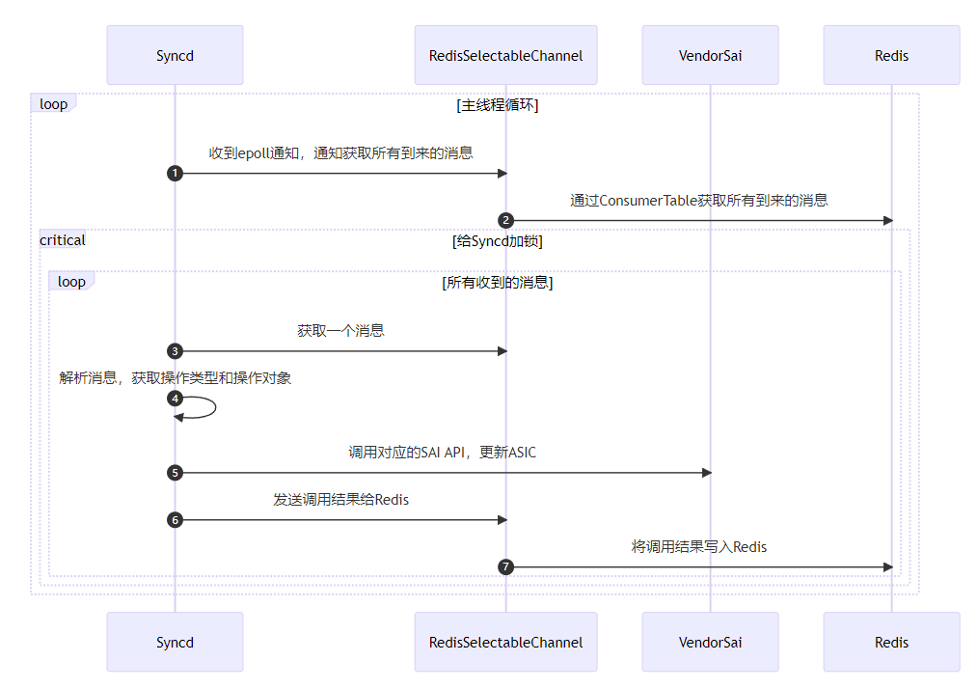首先，orchagent通过Redis发送过来的操作会被RedisSelectableChannel对象接收，然后在主循环中被处理。当Syncd处理到m_selectableChannel时，就会调用processEvent方法来处理该操作。这几步的核心代码我们上面介绍主循环时已经介绍过了，这里就不再赘述。

然后，processEvent会根据其中的操作类型，调用对应的SAI的API来对ASIC进行更新。其逻辑是一个巨大的switch-case语句，如下：

|  |
| --- |
| *// File: src/sonic-sairedis/syncd/Syncd.cpp* void Syncd::processEvent(_In_ sairedis::SelectableChannel& consumer) {  *// Loop all operations in the queue*  std::lock_guard<std::mutex> lock(m_mutex);  do {  swss::KeyOpFieldsValuesTuple kco;  consumer.pop(kco, isInitViewMode());  processSingleEvent(kco);  } while (!consumer.empty()); } sai_status_t Syncd::processSingleEvent(_In_ const swss::KeyOpFieldsValuesTuple &kco) {  auto& op = kfvOp(kco);  ...  if (op == REDIS_ASIC_STATE_COMMAND_CREATE)  return processQuadEvent(SAI_COMMON_API_CREATE, kco);  if (op == REDIS_ASIC_STATE_COMMAND_REMOVE)  return processQuadEvent(SAI_COMMON_API_REMOVE, kco);  ... } sai_status_t Syncd::processQuadEvent(  _In_ sai_common_api_t api,  _In_ const swss::KeyOpFieldsValuesTuple &kco) {  *// Parse operation*  const std::string& key = kfvKey(kco);  const std::string& strObjectId = key.substr(key.find(":") + 1);  sai_object_meta_key_t metaKey;  sai_deserialize_object_meta_key(key, metaKey);  auto& values = kfvFieldsValues(kco);  SaiAttributeList list(metaKey.objecttype, values, false);  sai_attribute_t *attr_list = list.get_attr_list();  uint32_t attr_count = list.get_attr_count();  ...  auto info = sai_metadata_get_object_type_info(metaKey.objecttype);  *// Process the operation*  sai_status_t status;  if (info->isnonobjectid) {  status = processEntry(metaKey, api, attr_count, attr_list);  } else {  status = processOid(metaKey.objecttype, strObjectId, api, attr_count, attr_list);  }  *// Send response*  if (api == SAI_COMMON_API_GET) {  sai_object_id_t switchVid = VidManager::switchIdQuery(metaKey.objectkey.key.object_id);  sendGetResponse(metaKey.objecttype, strObjectId, switchVid, status, attr_count, attr_list);  ...  } else {  sendApiResponse(api, status);  }  syncUpdateRedisQuadEvent(status, api, kco);  return status; } sai_status_t Syncd::processEntry(_In_ sai_object_meta_key_t metaKey, _In_ sai_common_api_t api,  _In_ uint32_t attr_count, _In_ sai_attribute_t *attr_list) {  ...  switch (api)  {  case SAI_COMMON_API_CREATE:  return m_vendorSai->create(metaKey, SAI_NULL_OBJECT_ID, attr_count, attr_list);  case SAI_COMMON_API_REMOVE:  return m_vendorSai->remove(metaKey);  ...  default:  SWSS_LOG_THROW("api %s not supported", sai_serialize_common_api(api).c_str());  } } |

## **3. ASIC状态变更上报**

反过来，当ASIC状态发生任何变化，或者需要上报数据，它也会通过SAI来通知我们，此时Syncd会监听这些通知，然后通过ASIC_DB上报给orchagent。其主要工作流如下：

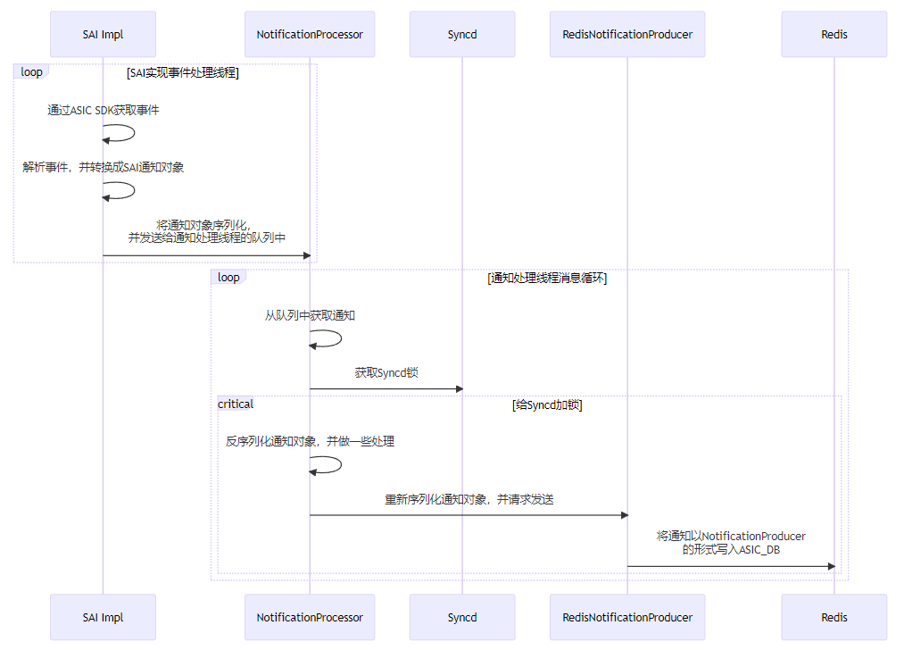

这里我们也来看一下具体的实现。为了更加深入的理解，我们还是借助开源的Mellanox的SAI实现来进行分析。

最开始，SAI的实现需要接受到ASIC的通知，这一步是通过ASIC的SDK来实现的，Mellanox的SAI会创建一个事件处理线程（event_thread），然后使用select函数来获取并处理ASIC发送过来的通知，核心代码如下：

|  |
| --- |
| *// File: platform/mellanox/mlnx-sai/SAI-Implementation/mlnx_sai/src/mlnx_sai_switch.c* static void event_thread_func(void *context) { #define MAX_PACKET_SIZE MAX(g_resource_limits.port_mtu_max, SX_HOST_EVENT_BUFFER_SIZE_MAX)  sx_status_t status;  sx_api_handle_t api_handle;  sx_user_channel_t port_channel, callback_channel;  fd_set descr_set;  int ret_val;  sai_object_id_t switch_id = (sai_object_id_t)context;  sai_port_oper_status_notification_t port_data;  sai_fdb_event_notification_data_t *fdb_events = NULL;  sai_attribute_t *attr_list = NULL;  ...  *// Init SDK API*  if (SX_STATUS_SUCCESS != (status = sx_api_open(sai_log_cb, &api_handle))) {  if (g_notification_callbacks.on_switch_shutdown_request) {  g_notification_callbacks.on_switch_shutdown_request(switch_id);  }  return;  }  if (SX_STATUS_SUCCESS != (status = sx_api_host_ifc_open(api_handle, &port_channel.channel.fd))) {  goto out;  }  ...  *// Register for port and channel notifications*  port_channel.type = SX_USER_CHANNEL_TYPE_FD;  if (SX_STATUS_SUCCESS != (status = sx_api_host_ifc_trap_id_register_set(api_handle, SX_ACCESS_CMD_REGISTER, DEFAULT_ETH_SWID, SX_TRAP_ID_PUDE, &port_channel))) {  goto out;  }  ...  for (uint32_t ii = 0; ii < (sizeof(mlnx_trap_ids) / sizeof(*mlnx_trap_ids)); ii++) {  status = sx_api_host_ifc_trap_id_register_set(api_handle, SX_ACCESS_CMD_REGISTER, DEFAULT_ETH_SWID, mlnx_trap_ids[ii], &callback_channel);  }  while (!event_thread_asked_to_stop) {  FD_ZERO(&descr_set);  FD_SET(port_channel.channel.fd.fd, &descr_set);  FD_SET(callback_channel.channel.fd.fd, &descr_set);  ...   ret_val = select(FD_SETSIZE, &descr_set, NULL, NULL, &timeout);  if (ret_val > 0) {  *// Port state change event*  if (FD_ISSET(port_channel.channel.fd.fd, &descr_set)) {  *// Parse port state event here ...*  if (g_notification_callbacks.on_port_state_change) {  g_notification_callbacks.on_port_state_change(1, &port_data);  }  }  if (FD_ISSET(callback_channel.channel.fd.fd, &descr_set)) {  *// Receive notification event.*  packet_size = MAX_PACKET_SIZE;  if (SX_STATUS_SUCCESS != (status = sx_lib_host_ifc_recv(&callback_channel.channel.fd, p_packet, &packet_size, receive_info))) {  goto out;  }   *// BFD packet event*  if (SX_TRAP_ID_BFD_PACKET_EVENT == receive_info->trap_id) {  const struct bfd_packet_event *event = (const struct bfd_packet_event*)p_packet;  *// Parse and check event valid here ...*  status = mlnx_switch_bfd_packet_handle(event);  continue;  }  *// Same way to handle BFD timeout event, Bulk counter ready event. Emiited.*  *// FDB event and packet event handling*  if (receive_info->trap_id == SX_TRAP_ID_FDB_EVENT) {  trap_name = "FDB event";  } else if (SAI_STATUS_SUCCESS != (status = mlnx_translate_sdk_trap_to_sai(receive_info->trap_id, &trap_name, &trap_oid))) {  continue;  }  if (SX_TRAP_ID_FDB_EVENT == receive_info->trap_id) {  *// Parse FDB events here ...*  if (g_notification_callbacks.on_fdb_event) {  g_notification_callbacks.on_fdb_event(event_count, fdb_events);  }  continue;  }  *// Packet event handling*  status = mlnx_get_hostif_packet_data(receive_info, &attrs_num, callback_data);  if (g_notification_callbacks.on_packet_event) {  g_notification_callbacks.on_packet_event(switch_id, packet_size, p_packet, attrs_num, callback_data);  }  }  }  } out:  ... } |

接下来，我们用FDB事件来举例，当ASIC收到FDB事件，就会被上面的事件处理循环获取到，并调用g_notification_callbacks.on_fdb_event函数来处理。这个函数接下来就会调用到Syncd初始化时设置好的NotificationHandler::onFdbEvent函数，这个函数会将该事件序列化后，通过消息队列转发给通知处理线程来进行处理：

|  |
| --- |
| *// File: src/sonic-sairedis/syncd/NotificationHandler.cpp* void NotificationHandler::onFdbEvent(_In_ uint32_t count, _In_ const sai_fdb_event_notification_data_t *data) {  std::string s = sai_serialize_fdb_event_ntf(count, data);  enqueueNotification(SAI_SWITCH_NOTIFICATION_NAME_FDB_EVENT, s); } |

而此时通知处理线程会被唤醒，从消息队列中取出该事件，然后通过Syncd获取到Syncd的锁，再开始处理该通知：

|  |
| --- |
| *// File: src/sonic-sairedis/syncd/NotificationProcessor.cpp* void NotificationProcessor::ntf_process_function() {  std::mutex ntf_mutex;  std::unique_lock<std::mutex> ulock(ntf_mutex);  while (m_runThread) {  *// When notification arrives, it will signal this condition variable.*  m_cv.wait(ulock);  *// Process notifications in the queue.*  swss::KeyOpFieldsValuesTuple item;  while (m_notificationQueue->tryDequeue(item)) {  processNotification(item);  }  } } *// File: src/sonic-sairedis/syncd/Syncd.cpp* *// Call from NotificationProcessor::processNotification* void Syncd::syncProcessNotification(_In_ const swss::KeyOpFieldsValuesTuple& item) {  std::lock_guard<std::mutex> lock(m_mutex);  m_processor->syncProcessNotification(item); } |

接下来就是事件的分发和处理了，syncProcessNotification函数是一系列的if-else语句，根据事件的类型，调用不同的处理函数来处理该事件：

|  |
| --- |
| *// File: src/sonic-sairedis/syncd/NotificationProcessor.cpp* void NotificationProcessor::syncProcessNotification( _In_ const swss::KeyOpFieldsValuesTuple& item) {  std::string notification = kfvKey(item);  std::string data = kfvOp(item);  if (notification == SAI_SWITCH_NOTIFICATION_NAME_SWITCH_STATE_CHANGE) {  handle_switch_state_change(data);  } else if (notification == SAI_SWITCH_NOTIFICATION_NAME_FDB_EVENT) {  handle_fdb_event(data);  } else if ...  } else {  SWSS_LOG_ERROR("unknown notification: %s", notification.c_str());  } } |

而每个事件处理函数都类似，他们会对发送过来的事件进行反序列化，然后调用真正的处理逻辑发送通知，比如，fdb事件对应的handle_fdb_event函数和process_on_fdb_event：

|  |
| --- |
| *// File: src/sonic-sairedis/syncd/NotificationProcessor.cpp* void NotificationProcessor::handle_fdb_event(_In_ const std::string &data) {  uint32_t count;  sai_fdb_event_notification_data_t *fdbevent = NULL;  sai_deserialize_fdb_event_ntf(data, count, &fdbevent);  process_on_fdb_event(count, fdbevent);  sai_deserialize_free_fdb_event_ntf(count, fdbevent); } void NotificationProcessor::process_on_fdb_event( _In_ uint32_t count, _In_ sai_fdb_event_notification_data_t *data) {  for (uint32_t i = 0; i < count; i++) {  sai_fdb_event_notification_data_t *fdb = &data[i];  *// Check FDB event notification data here*  fdb->fdb_entry.switch_id = m_translator->translateRidToVid(fdb->fdb_entry.switch_id, SAI_NULL_OBJECT_ID);  fdb->fdb_entry.bv_id = m_translator->translateRidToVid(fdb->fdb_entry.bv_id, fdb->fdb_entry.switch_id, true);  m_translator->translateRidToVid(SAI_OBJECT_TYPE_FDB_ENTRY, fdb->fdb_entry.switch_id, fdb->attr_count, fdb->attr, true);  ...  }  *// Send notification*  std::string s = sai_serialize_fdb_event_ntf(count, data);  sendNotification(SAI_SWITCH_NOTIFICATION_NAME_FDB_EVENT, s); } |

具体发送事件的逻辑就非常直接了，最终就是通过[NotificationProducer](http://r12f.com/posts/sonic-5-syncd-sai-workflow/4-2-2-redis-messaging-layer.html" \l "notificationproducer--notificationconsumer)来发送通知到ASIC_DB中：

|  |
| --- |
| *// File: src/sonic-sairedis/syncd/NotificationProcessor.cpp* void NotificationProcessor::sendNotification(_In_ const std::string& op, _In_ const std::string& data) {  std::vector<swss::FieldValueTuple> entry;  sendNotification(op, data, entry); } void NotificationProcessor::sendNotification(_In_ const std::string& op, _In_ const std::string& data, _In_ std::vector<swss::FieldValueTuple> entry) {  m_notifications->send(op, data, entry); } *// File: src/sonic-sairedis/syncd/RedisNotificationProducer.cpp* void RedisNotificationProducer::send(_In_ const std::string& op, _In_ const std::string& data, _In_ const std::vector<swss::FieldValueTuple>& values) {  std::vector<swss::FieldValueTuple> vals = values;  *// The m_notificationProducer is created in the ctor of RedisNotificationProducer as below:*  *// m_notificationProducer = std::make_shared<swss::NotificationProducer>(m_db.get(), REDIS_TABLE_NOTIFICATIONS_PER_DB(dbName));*  m_notificationProducer->send(op, data, vals); } |

到此，Syncd中的通知上报的流程就结束了。

## **4. 参考资料**

[SONiC Architecture](https://github.com/sonic-net/SONiC/wiki/Architecture" \t "http://r12f.com/posts/sonic-5-syncd-sai-workflow/_blank)

[Github repo: sonic-sairedis](https://github.com/sonic-net/sonic-sairedis/" \t "http://r12f.com/posts/sonic-5-syncd-sai-workflow/_blank)

[Github repo: Nvidia (Mellanox) SAI implementation](https://github.com/Mellanox/SAI-Implementation/tree/master" \t "http://r12f.com/posts/sonic-5-syncd-sai-workflow/_blank)